Thin Ice – Cowichan Lake Dist. Skating Club- June 2017

Cowichan Lake Dist. Skating club had a very successful season. Many badges passed in Canskate. We had a Halloween Skate in October. The highlight of the season was our Ice Show in March “Under the Sea”. A special thank-you to our program assistant’s Morgan and Sarah for all their help through the season.

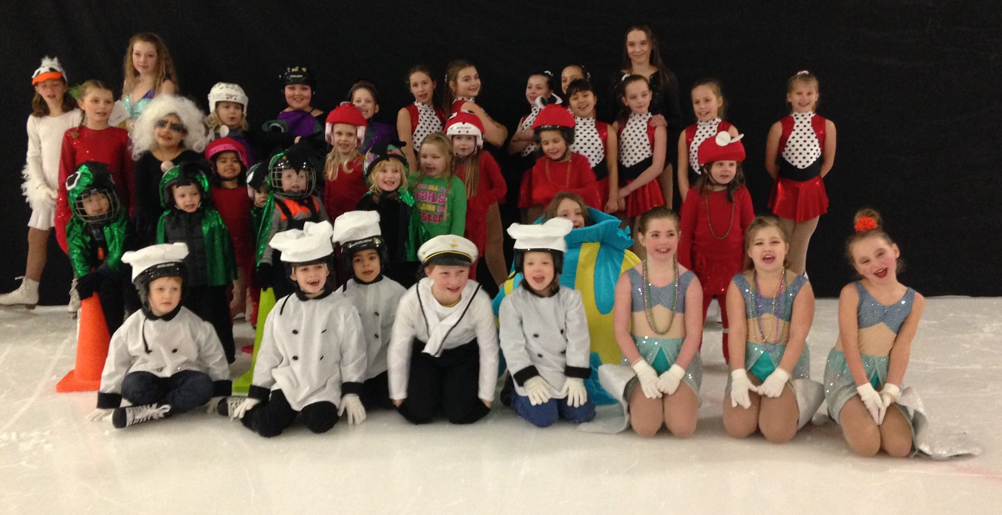
Cowichan Lake Dist. Skating Club – Ice Show “Under the Sea”

